HOW TO RUN *“THE SECRET RACE”*

Equipment needed:

1. A 4-combination lock
2. An email inbox with two aliases that have two different auto-responses.
3. A printer!

Note: This puzzle below is set up for a 4-combination lock with the following numbers 5 3 1 3. Simply amend the numbers below for a different combination.

Set up a phone to emit Morse (preferably with sound *and* light):

*“6 NW room corner”*

(feel free to replace NW whatever direction is best for the room you’re using).

And/Or use the below Braille (to provide an alternative for the difficulty of decoding Morse (Why? iPhone’s don’t have an easily available app that can decide Morse, hence the Braille alternative)).

*or*⠼⠋ ⠝⠺ ⠗⠕⠕⠍ ⠉⠕⠗⠝⠑⠗

?

*(It’s recommended to put this question mark up near your flashing phone / Braille start as this will help potential players realise that it is meant to be a puzzle…without being too obvious.)*

Print and hide the below message out obvious of sight, in the corner of the room in the direction (e.g. NW) you specified:

*“****Congratulations!*** *You solved the Morse or Braille code to find the entrance to the “The Secret Race” (if you have no idea what we’re talking about then it's a good idea to find and solve that first)!*

*Your reward is the second magic number: 4. (Do you remember the number you decoded from the first part of the race!)  
Very important: You must keep all the magic numbers you receive, and keep them in order!  
  
This is a race! You may pair up, but know that there is just one prize, for fastest time.   
Along the way you’ll find numbers, you’ll need them at the end to get to the end of the race and stop your timer.*

*To receive your next clue, email your team name, as the subject line,  to* [race+start@softwaretester.co.za](mailto:race+start@softwaretester.co.za) *E.g. Subject “Team Fast Friends”.  
  
Note: Once you send this mail, your race timer STARTS!*

The players email the inbox, and receive the auto-response you’ve set up:

*“You’re on your way! The* ***third magic number is*** *2.  
Your clue for the next part of the race: “Only trust the* ***GREEN*** *QR code”*Note: You can include some help here e.g.*“Only trust the* ***GREEN*** *QR code,* ***behind the door****”*

They find the QR code poster (which you have printed and hidden; see poster attached below) somewhere in the room, decode the hex value of the color. The correct QR code leads them to a raw Github page (ensure the other QR codes lead to fake instructions, that they should not trust):   
For this example, the QR code they can trust leads them to the follow text online:

*The fourth and final magic number is 4.   
Now take each of the magic numbers you've received in the order you received,   
Minus 1 from each of them.   
That’s the code to the unlock the seal in the centre of the room…Hurry!*

Players take all the numbers they’ve received so far, in order, (6, 4, 2, and now 4), and minus 1 from each to unlock the lock with 5, 3, 1, 5.   
Inside the, now unlocked, box/bag they find a note:

***You made it!*** *Quickly email your team name* ***& the Morse/Braille code magic number*** *to* [*race+end@softwaretester.co.za*](mailto:race+end@softwaretester.co.za) *to finish the race and stop your timer.   
Please lock this note back up now.*

The players email the inbox, and receive the second auto-response you’ve set up:

*Congratulations, you completed The Secret Race.  
The fastest team wins the prize!   
Winners will be announced at prize giving at the end of the workshop.*

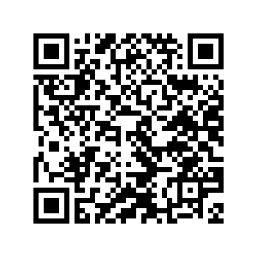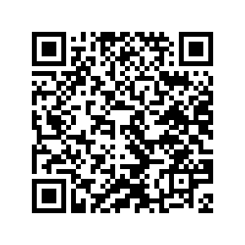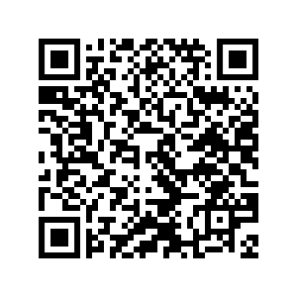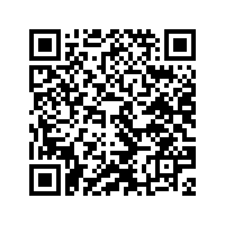

**#FFC300**

**#626567**

**#17202A**

**#D43030**

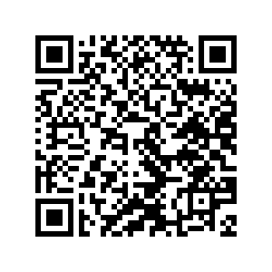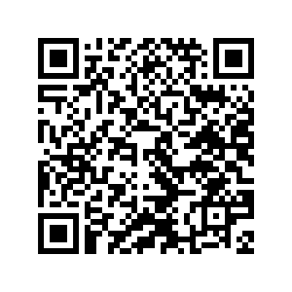

**#304BD4**

**#30D46**